BUILDING A RETAIL SALE DATA AGENT
NAME: PHUTI MARUTLA
STUDENT NUMBER: 2805001684
DATE: 24 MAY 2026

2. Introduction
The purpose of this project was to build a Retail Sales Data Agent using Databricks. The project involved uploading a retail sales dataset, analysing the data, creating an AI agent, testing business questions, validating results, and publishing the work to GitHub. The objective was to gain practical experience in data analysis and AI-powered business intelligence.

3. Dataset Description
The dataset contains retail sales transaction data with the following key fields:
Column | Description
Customer ID | Unique identifier for customers
Product Category | Product category such as Electronics, Home, Clothing, Grocery
Quantity | Number of units sold
Price per Unit | Selling price per product
Total Amount | Total sales value per transaction
Date | Transaction date

Missing Columns
The dataset does not contain:
- Gender
- Age
Therefore, demographic analysis by customer gender or age cannot be performed unless another customer demographics dataset is added.

Sales Analysis Results

1. Total Sales Amount
The total sales amount for all products was:

$8,403,425
Additional statistics:
- Total Orders: 5,000
- Total Units Sold: 9,959

2. Total Products Sold
The total number of products sold was:

9,959 units

3. Highest Revenue Product
The product generating the highest revenue was:

Belkin Accessories Air
Metric | Value
Revenue | $320,054
Units Sold | 188
Orders | 95
Average Unit Price | $1,904

4. Highest Revenue Category
The category with the highest revenue was:

Electronics
Metric | Value
Revenue | $6,757,501
Revenue Contribution | 80.4%
Units Sold | 4,892
Orders | 2,425
Average Order Value | $2,787
Electronics generated:
4.5 times more revenue than home category.

5. Average Selling Price
Metric | Value
Average Unit Price | $932
Minimum Price | $4
Maximum Price | $2,499
Average Transaction Value | $1,681

6. Highest Transaction
The highest individual transaction recorded was:
Field | Value
Order ID | O900536
Date | 2024-11-17
Product | Samsung Tablets Plus
Quantity | 4
Unit Price | $2,499
Total Amount | $9,996
Customer | C00775
Store | Value Mart - Manchester

7. Apple Phones Basic Performance
Metric | Value
Orders | 54
Units Sold | 107
Revenue | $187,666
Average Unit Price | $1,916
This product appeared multiple times in the top 10 highest-value transactions.

8. Apple vs Samsung Comparison

Total Revenue Comparison
Brand | Revenue
Samsung | $1,586,517
Apple | $1,221,737
Samsung generated approximately:

30% more revenue than Apple.

Sales Volume Comparison
Brand | Units Sold | Orders | Avg Unit Price
Samsung | 1,197 | 595 | $1,438
Apple | 746 | 365 | $1,844

Key Insight
- Samsung sold more units.
- Apple products had higher premium pricing.

Average Order Value
Brand | Average Order Value
Apple | $3,347
Samsung | $2,666
Apple customers spent:

26% more per transaction.

9. Top 10 Highest Sales Transactions
Date | Product | Quantity | Price per Unit | Total Amount
2024-11-17 | Samsung Tablets Plus | 4 | $2,499 | $9,996
2024-10-01 | Apple Phones Basic | 4 | $2,340 | $9,360
2024-12-30 | Apple Phones Basic | 4 | $2,340 | $9,360
2024-03-30 | Apple Phones Basic | 4 | $2,340 | $9,360
2024-06-16 | Apple Phones Basic | 4 | $2,340 | $9,360
2024-04-24 | Apple Tablets Max | 4 | $2,303 | $9,212
2024-08-12 | Samsung Phones Basic | 4 | $2,296 | $9,184
2024-10-06 | Anker Accessories Pro | 4 | $2,280 | $9,120
2024-03-30 | Samsung Tablets Plus | 4 | $2,499 | $8,996
2024-11-21 | Acer Laptops Basic | 4 | $2,435 | $8,961

Key Business Insights

Revenue Drivers
- Electronics dominate overall business performance.
- High-end electronics generate the largest transaction values.

Brand Strategy
- Samsung focuses on high-volume sales.
- Apple focuses on premium pricing and higher-value customers.

Purchasing Patterns
- Most top-value transactions involved:
  - exactly 4 units,
  - indicating bulk purchasing behaviour.

Product Trends
Top-performing products include:
- Samsung Tablets Plus
- Apple Phones Basic
- Belkin Accessories Air
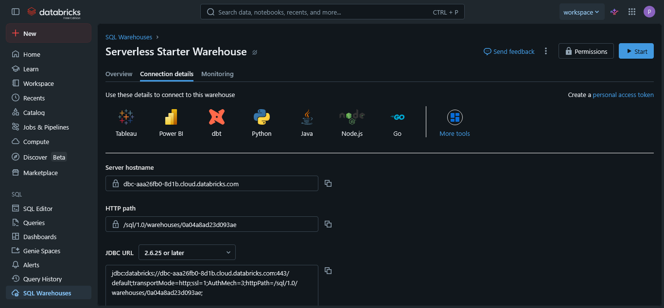
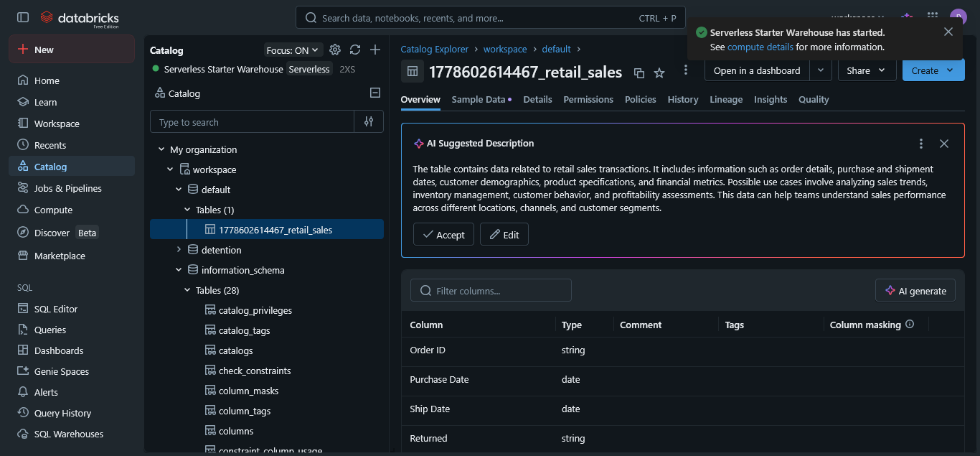
4. Used the retail sale table to answer questions related to

- What is the total sales amount for all products?

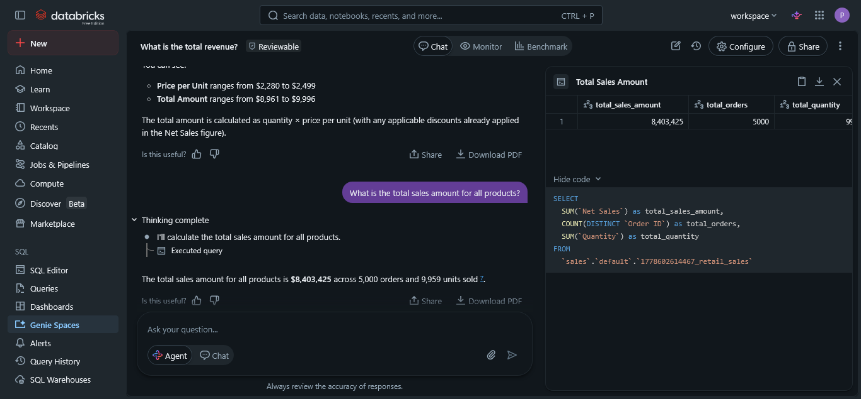

- How many total products were sold?
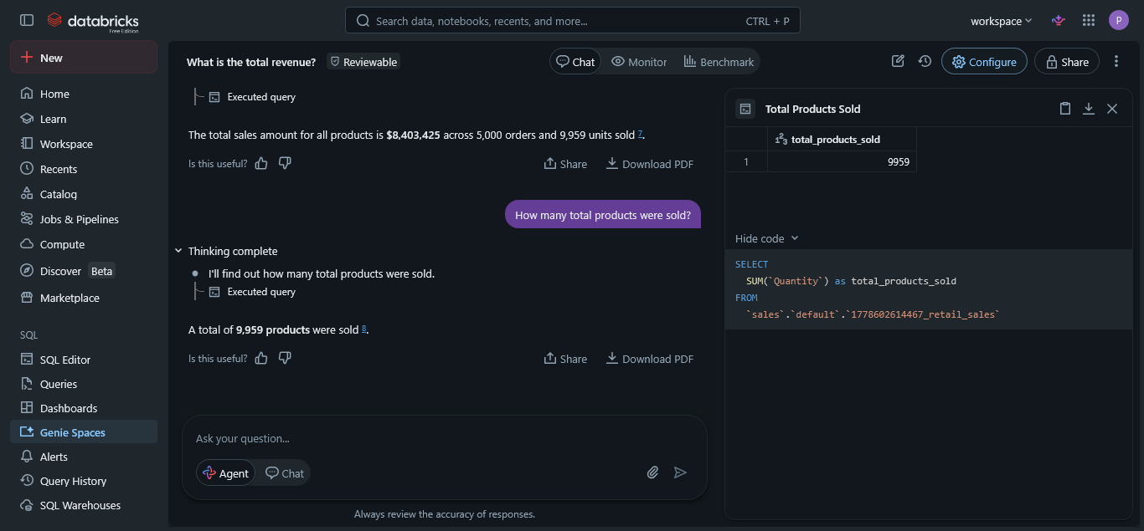

- Which product generated the highest revenue?
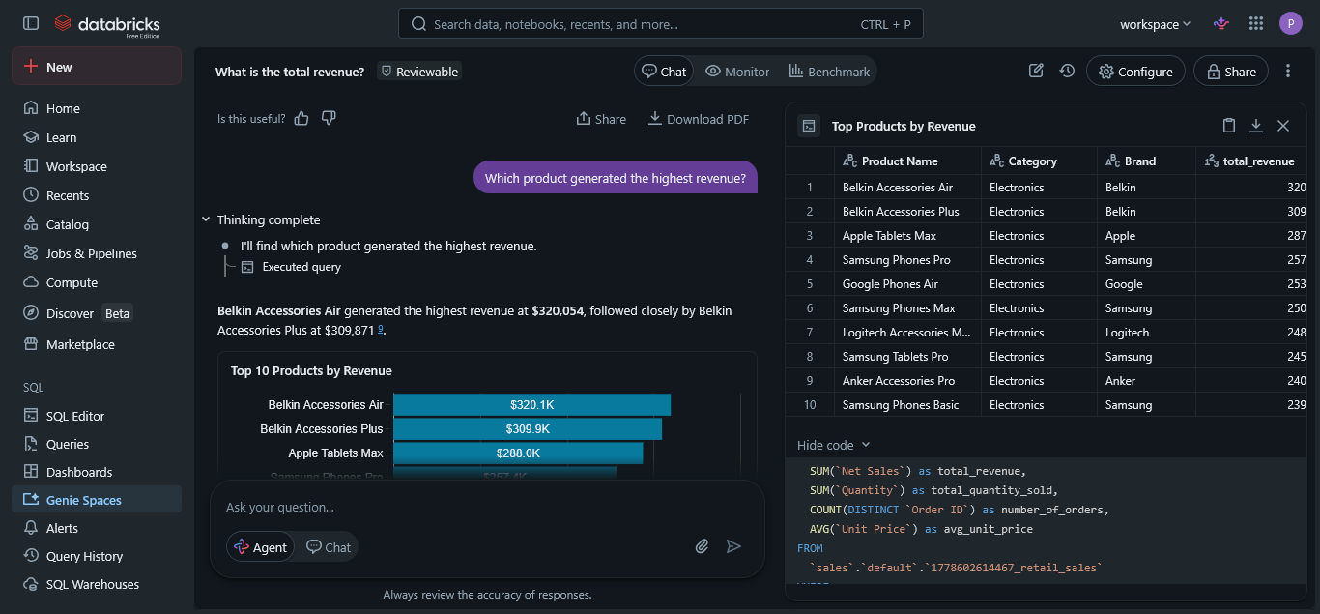
- Which category generated the most revenue?
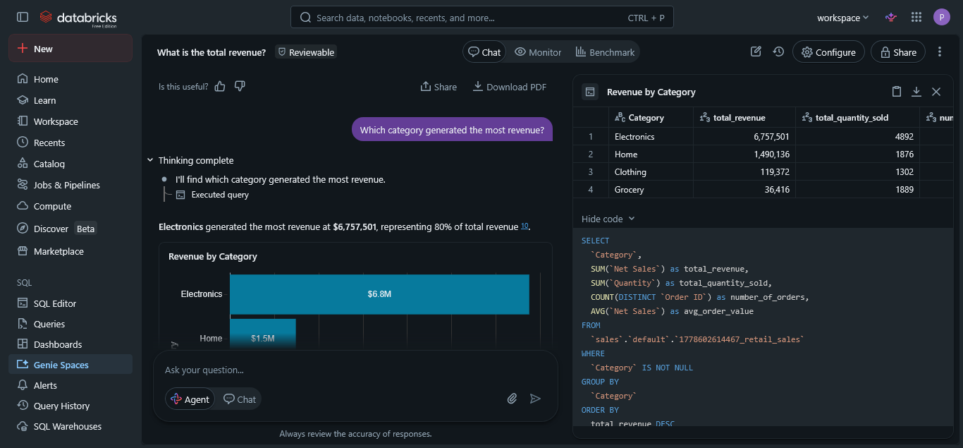

- What is the average selling price of all products?
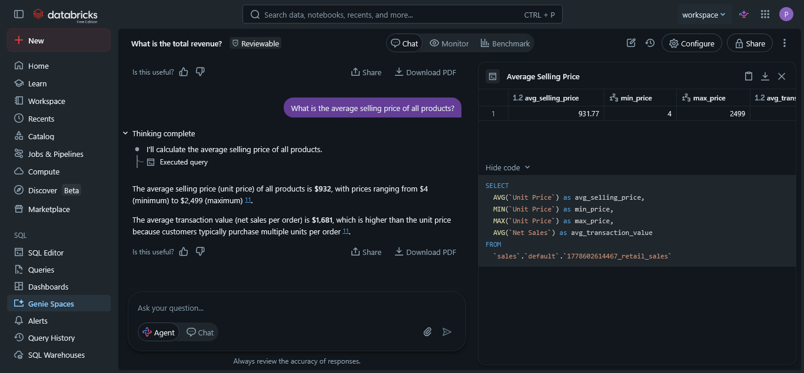

- Which transaction had the highest total amount?
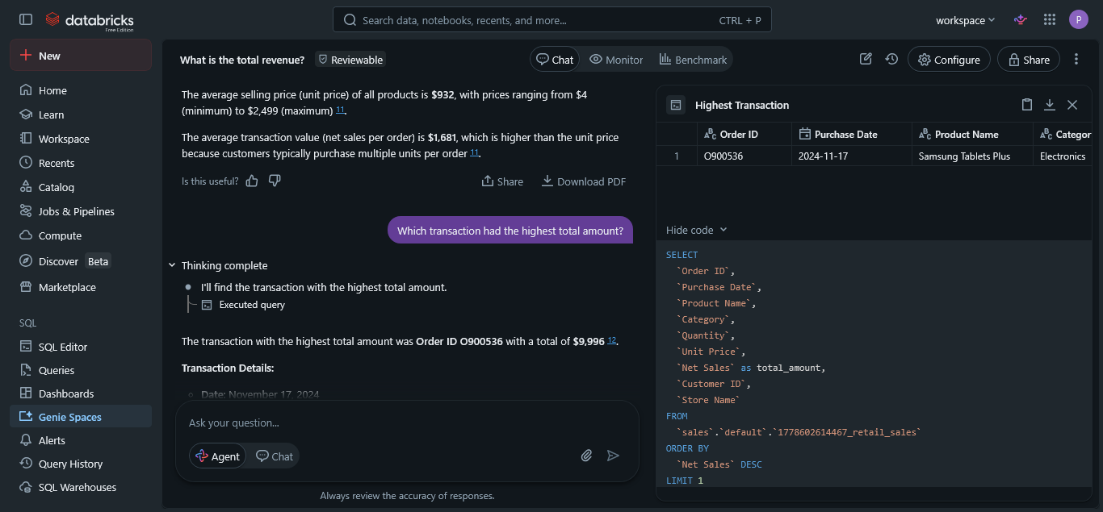

- What is the total revenue for Electronics?

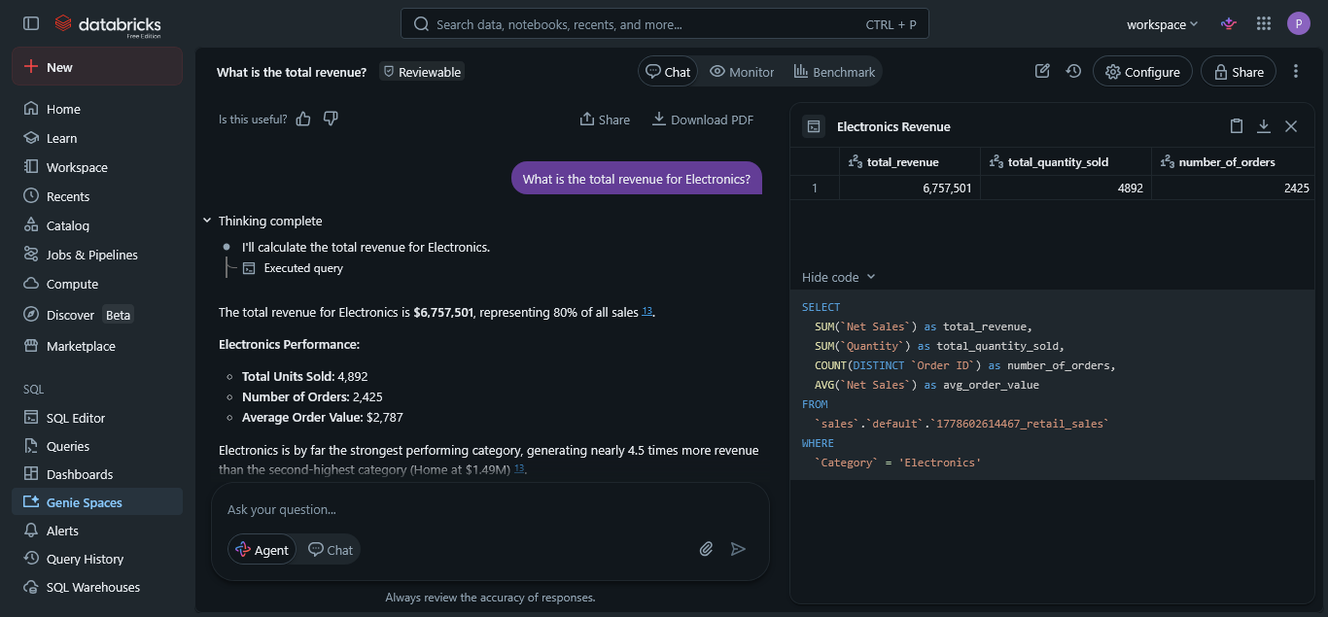

- How many times was “Apple Phones Basic” sold?
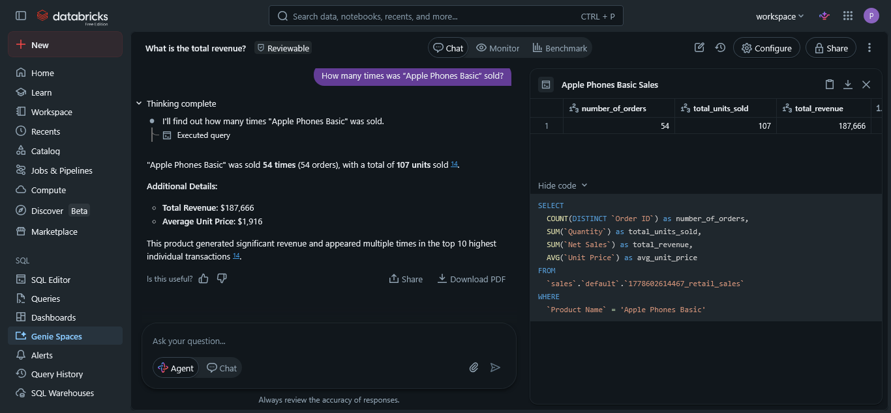

- Compare Apple vs Samsung total sales?
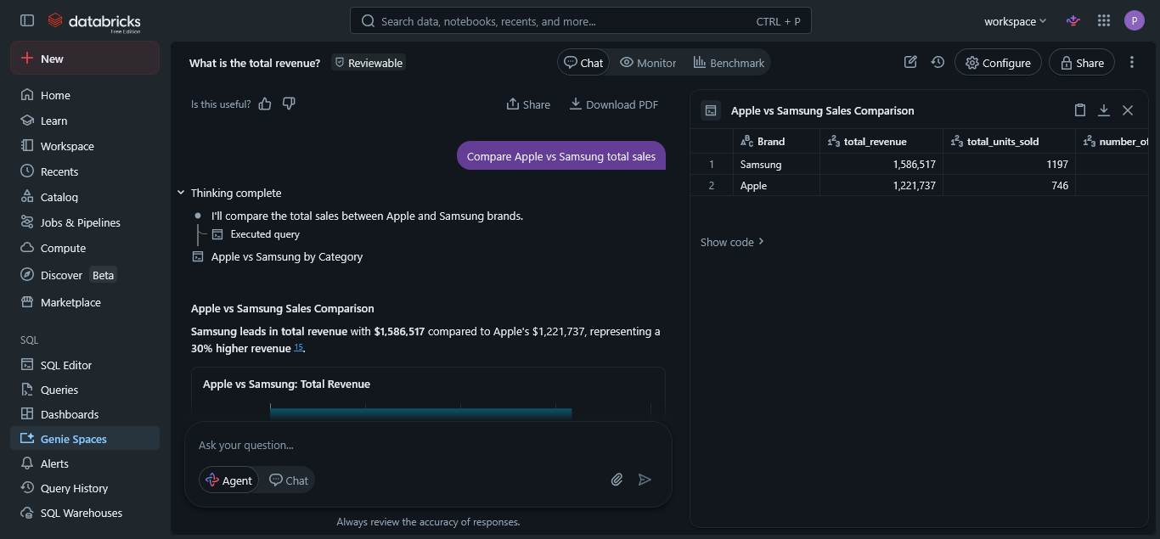
- What is the total revenue for Electronics?
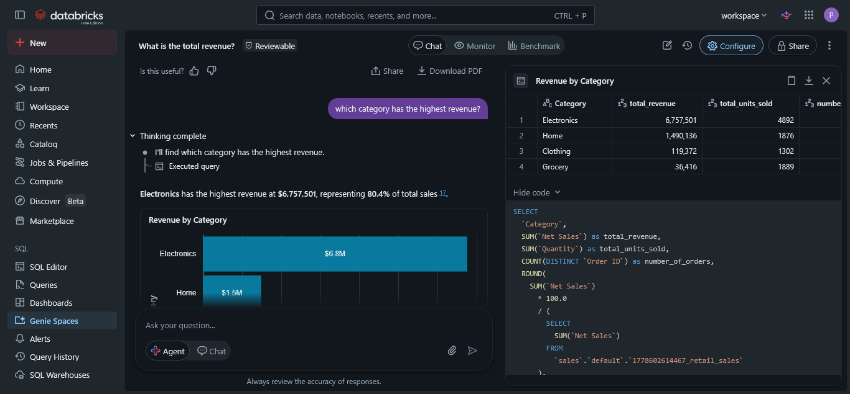

Validation Analysis
The following validation checks were conducted within the retail sales dataset analysis to confirm the accuracy, consistency, and reliability of the transactional information.
  - Validation of Total Sales Amount
Analysis was conducted by aggregating all values reflected under the Total Amount column to verify the total organizational revenue generated from all recorded transactions.
The validation confirmed that:

Total Revenue = $8,403,425
  - The Quantity column was analysed by summing all units sold across the dataset.

Total Units Sold = 9,959

Business Recommendations
- Increase investment in the Electronics category because it generates the highest revenue.
- Maintain higher stock levels for top-selling products such as Samsung Tablets Plus and Apple Phones Basic.
- Introduce targeted marketing campaigns for premium electronic products to increase sales.
- Improve inventory management and sales forecasting using historical sales data.
- Expand customer retention strategies to encourage repeat purchases from high-value customers.

Conclusion
The project successfully analysed retail sales data to evaluate revenue performance, product demand, and category profitability. The analysis revealed that the Electronics category was the highest revenue contributor, generating approximately 80.4% of total sales. The project also identified top-performing products, customer purchasing patterns, and brand performance differences between Apple and Samsung. Overall, the project demonstrated how data analytics and business intelligence techniques can support informed business decision-making, sales forecasting, and strategic planning.

